**Summit County Dispersed Camping**

*If you have any questions on where you can camp, please ask for information at the Dillon Ranger District office, phone (970)-468-5400*

**Restrictions -** Camping more than 28 days within a continuous 60 day period, when not otherwise restricted, and occupying any campsite for more than 14 days during this 60 day period within 3 miles of the previous campsite where not otherwise restricted is prohibited. Residing on National Forest System (NFS) Lands is prohibited.

Dispersed camping within the Eagle’s Nest and Ptarmigan Peak **Wilderness Areas** are subject to the following additional restrictions. All of the following are prohibited:

1.  Entering or being in the area with more than 15 people per group with a maximum combination of 25 people and pack or saddle animals in any one group.

2.  Camping  within one hundred (100) feet of any lake, stream, Forest Development Trail, or any "No Camping" or "Wilderness Restoration Site" signs.

3.  Building, maintaining, attending, or using a campfire within one hundred (100) feet of any lake, stream, or Forest Development Trail or within ¼  mile of treeline or above treeline. **NO fires in Stage 1 or Stage 2 restrictions.**    
4.  Storing equipment, personal property, or supplies for longer than 72 hours.

5.   Hitching, tethering or hobbling any pack or saddle animal within one hundred (100) feet of any lake, stream, and Forest Development Trail.

6.   Possessing a dog, except  working stock dogs or dogs used for legal hunting purposes**, unless under physical restraint of a leash not to exceed six (6) feet in length.**

7.  Possessing, storing, or transporting any plant material, such as hay or straw.  **Note:**  Exceptions are allowed for livestock feed and bedding that has been **certified weed free**.

8.   Possessing or using a wagon, cart, or other vehicle, including wheelbarrows and game carts.

9.  Shortcutting a switchback in a trail.

Vehicles **MUST** remain on the road shoulder or in widened pull-outs, where they won’t interfere with traffic or damage vegetation. A vehicle may travel 300 feet off a NFS road to camp given it does not cause resource damage.

**Campfires** - NO FIREWOOD CUTTING except dead and downed wood.  Please make use of existing campsites and fire rings instead of creating a new site. When finished with the campfire ring, pack out unburned trash - leave the site clean for the next campers.

***Build a fire only as large as is needed.  Never leave a campfire unattended.***

***When you are done with the fire or leaving the campsite make sure the fire is DEAD out!***

**Trash** - Pack out all trash.

**Washing -** Use biodegradable soaps.  Dig a small hole to pour the soapy water into after you finish washing - this prevents bits of food and soap from polluting the area around your camp. **Remember:**Soap pollutes the water and injures fish and other aquatic animals -please do not wash in lakes and streams!

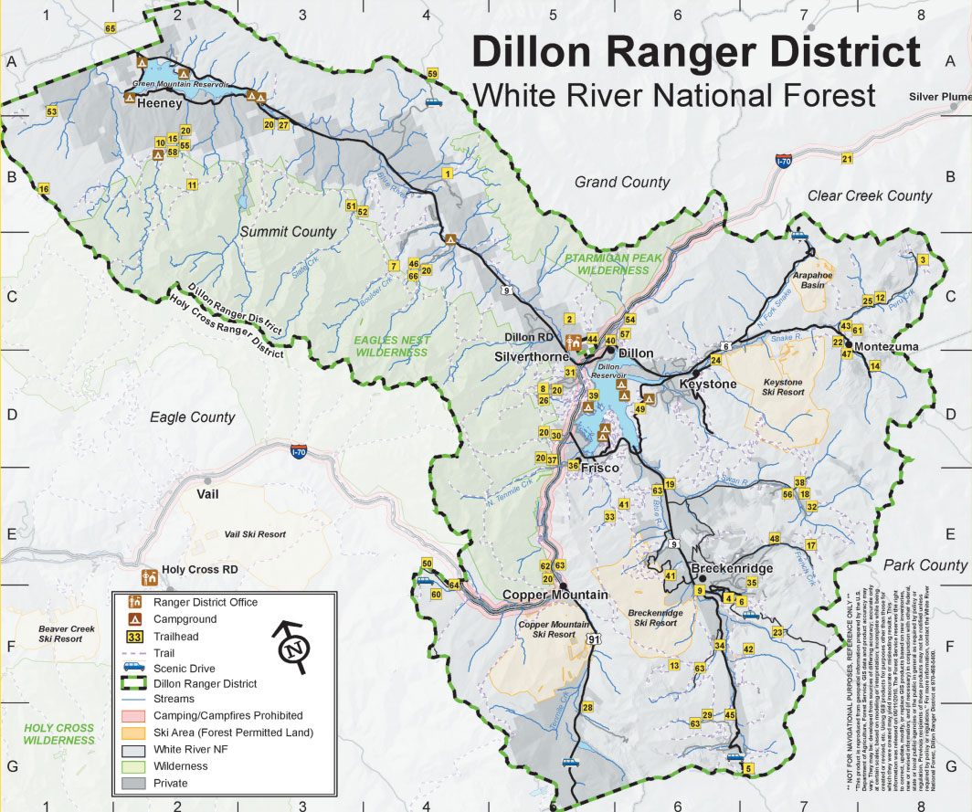

**Check the “Conditions Report” on fs.usda.gov/whiteriver for gate status**

**Green Mountain Reservoir (N of Silverthorne on Hwy 9) Frisco (Near Peak One Drive)**

**1** Spring Creek Road: 2WD/4x4 (N of GMR) **13** Miners Creek Rd: 4WD (No camping for first 1.5 miles)

**2** Williams Peak Road: 4WD (N of GMR)

**3** Brush Creek Road: 4x4 (S of GMR) **Tiger Road (S of Frisco on Hwy 9)**

**14** North Fork Swan River: 2WD/4WD

**Blue River (N of Silverthorne on Hwy 9) 15** Middle Fork Swan River: 2WD/4WD

**4** Ute Pass Road: Near top of pass **16** Georgia Pass Road: 2WD/4WD

**5** Columbine Landing: Do not block boat access

**6** North Rock Creek Road: 2WD/4x4* - designated dispersed **Boreas Pass (S of Breckenridge on Hwy 9)**

**17** Boreas Pass Road: 2WD/4WD – designated dispersed

**Keystone (E of Dillon on Hwy 6) 18** Indiana Creek Road: 4x4 (off Wagon Rd)

**7** Keystone Gulch Road: 2WD/4WD (via Soda Ridge Rd)* **19** Spruce Creek Road: 2WD/4WD

**20** Crystal Lakes *via Spruce Creek Road*: 4WD (R at first junction)

**Montezuma (E of Dillon on Hwy 6) 21** Pennsylvania Creek Road: 4x4 (via Coronet Rd)

**9** Peru Creek Road: 4WD* - designated dispersed

**10** Deer Creek Road: 4WD (watch for private property)

**11** St Johns Road: 4WD (watch for private property) **Vail Pass Rest Area (W of Frisco on 1-70, Exit 190)**

**12** Webster Pass Road: 4WD **22** Shrine Pass Road: 2WD/4WD (can camp 300’ from center line of the road, 100’ from water unless otherwise designated)

***\*Area requiring proper bear-resistant food/trash/odorous material storage. Refer to Forest Order handout for information.***

**22**

**21**

**20**

**19**

**18**

**17**

**16**

**15**

**14**

**13**

**12**

**11**

**10**

**9**

**7**

**6**

**5**

**4**

**3**

**2**

**1**

**13**

**23**